Major sources that make up the General Fund total revenue include: Ad Valorem/Property Taxes (28.3%), Sales and Use Tax (1.4%), Franchise Fees (4.4%), Utility Taxes (10.6%), Intergovernmental (5.1%), Charges for Services (7.5%), Licenses & Permits (0.8%), Fines & Forfeitures (1.4%), Miscellaneous (22.7%), and Balances, Reserves, and Transfers (17.7%).

The five-year estimates for both revenues and expenditures in this section were taken from the financial forecasting model provided by Burton and Associates during the FY 2014 budget cycle. A description of each revenue source as well as a discussion and outlook for next year follows.

**Ad Valorem Taxes**

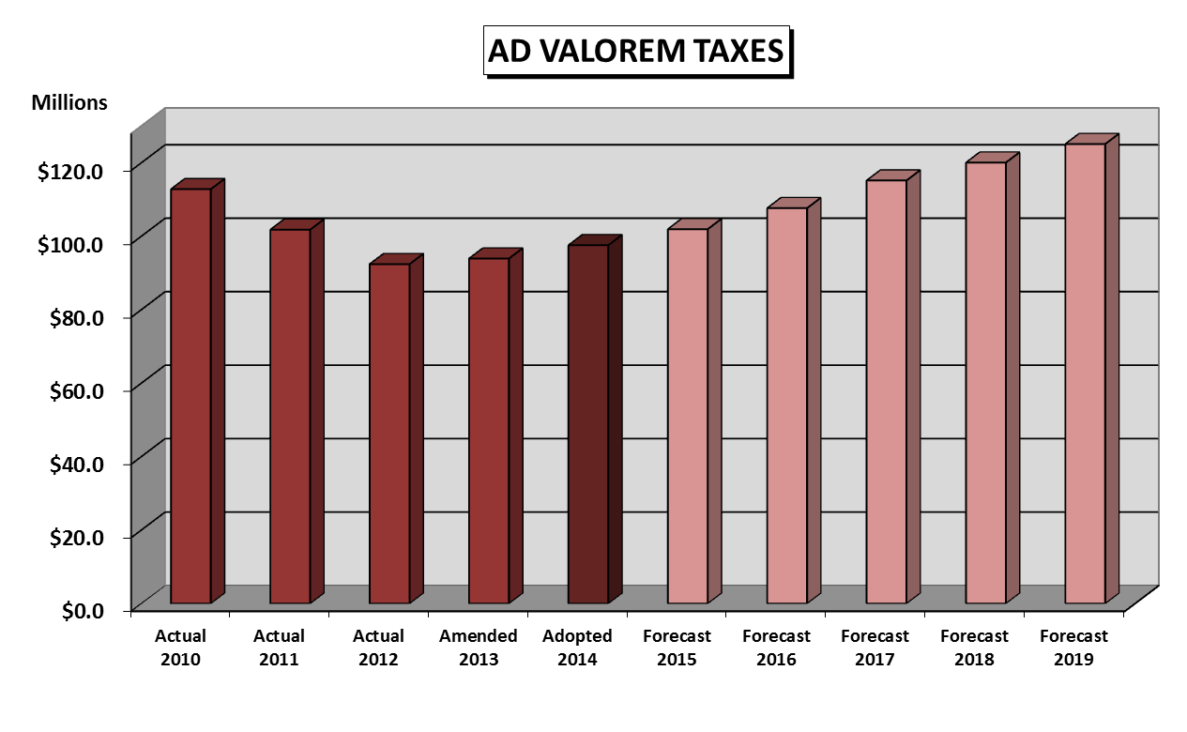The adopted ad valorem or property tax millage for operating purposes is 4.1193 and generates $97,569,296 million, or 28.3% of the General Fund revenue. The tax rate is made up of two components: operating millage rate and voted debt millage rate. A separate debt levy is used to pay debt service costs (principal and interest payments) associated with outstanding General Obligation Bonds (GOB). The revenue collected from the debt levy is deposited into the Debt Service Fund.

Over the last few years, property taxable values have been stable and a slight increase in values is noticeable. The City anticipates steady growth over the next few years. For the FY 2014 tax roll, property taxable values increased by 4.5%.

The current outstanding debt issues include the General Obligation Fire Bond 2005, and the General Obligation Refunding Bonds 2011A and 2011B. The adopted debt service payment for the 2005 Fire Bond Issue is $1,182,011, which requires a levy of $1,182,368 and a millage of 0.0505. The adopted debt service payment for the General Obligation Refunding Bonds 2011A is $1,146,600, which requires a levy of $1,147,248 and adopted millage of 0.0490. The adopted debt service payment for the General Obligation Refunding Bonds 2011B is $2,518,650, which requires a levy of $2,516,922 and adopted millage of 0.1075. The Debt Service levy totals $4,846,538. The City’s combined Debt Service for FY 2014 is $34.6 million. The adopted combined millage for operating and debt service for FY 2014 is 4.3263, which represents a .18% decrease from the 4.3342 FY 2013 combined millage.

**Franchise Fees**

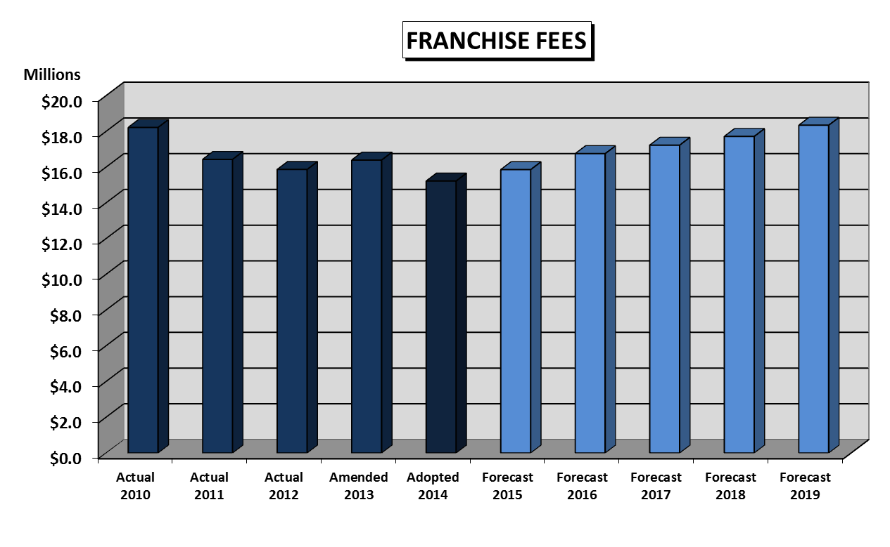This revenue source consists of payments made by Florida Power and Light (FPL) and Peoples Gas for the privilege of constructing upon, and operating within, the rights-of-way owned by the City. The basis for the fees is provided for in long-term agreements for payment to the City of 6.0% of their gross revenue derived from accounts within the City limits, less property tax and minor fees previously paid to the City. Projected FPL and Peoples Gas franchise fees for FY 2014 are $15,228,206, which represents a decrease of 7.1% from the FY 2013 amended budget.

**Sales & Use Taxes**

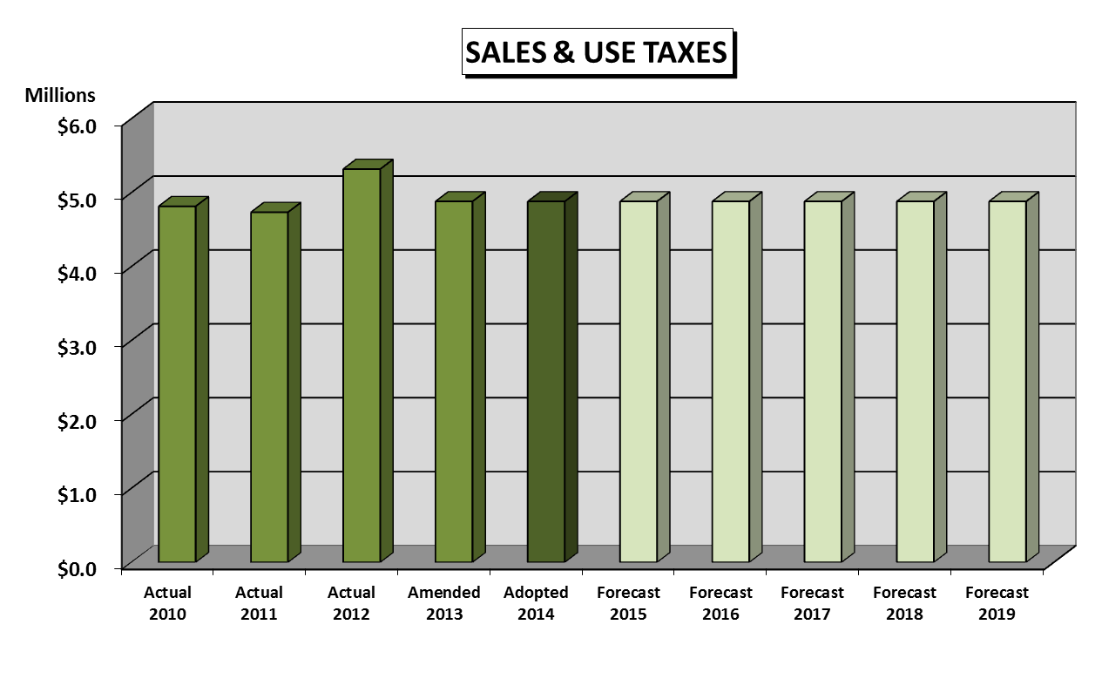Florida Statutes provide for the levy of excise taxes of 1.85% on fire insurance premiums and 0.85% on casualty insurance premiums. These funds are passed through the General Fund as revenue and an expense. Proceeds of these taxes are distributed to eligible municipalities to supplement the Pension and Retirement Trust funds for firefighters and police officers. The adopted revenue for FY 2014 is $­­­­­­4,882,276 and is the same as the FY 2013 amended budget. A rate increase is not projected in future years.

**Utility Taxes**

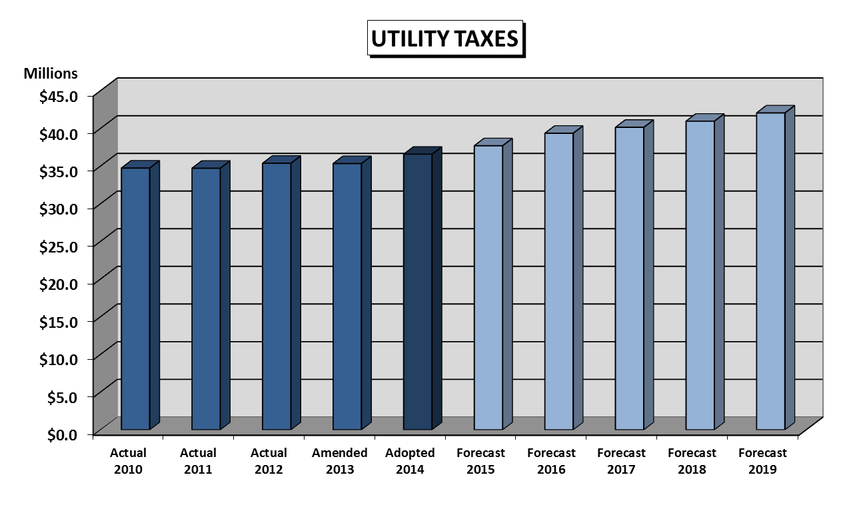This category is comprised of three major components. The largest component is the City utility tax on electricity, charged by FPL to its customers. FPL utility tax is projected to be 50.7% of the adopted FY 2014 utility tax revenues. The second-largest source for this revenue category is the State Communications Services Tax. This tax represents 34.5% of the adopted FY 2014 utility tax revenue, based upon estimates from the Florida Department of Revenue. The third component of utility tax revenue consists of the combination of the City’s utility tax on gas and water utility bills for customers within the City. Water utility taxes increase as water rates increase. The adopted revenue for FY 2014 is $36,592,965, which represents a 3.5% increase from the FY 2013 amended budget.

**Charges for Services**

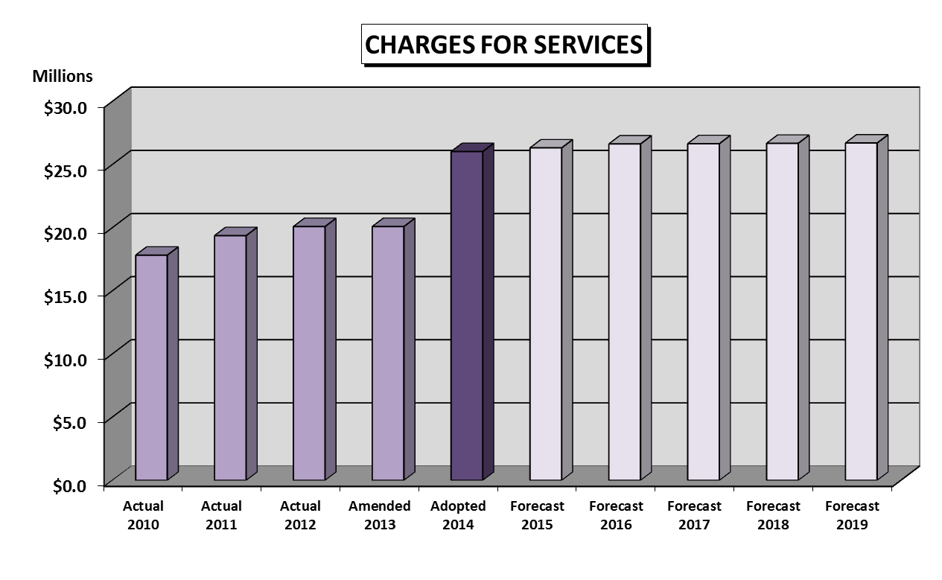This category is associated with revenue received from users of specific services, including fees for police, fire related inspections, planning, and docks, as well as parks and recreation. The adopted revenue for FY 2014 is $26,036,670, which represents a 29.6% increase from the FY 2013 amended budget. The increase is primarily associated with the taxes collected on properties that are currently leased to outside organizations and the general fund recognition of sanitation related private collector fees.

**Licenses & Permit Fees\***

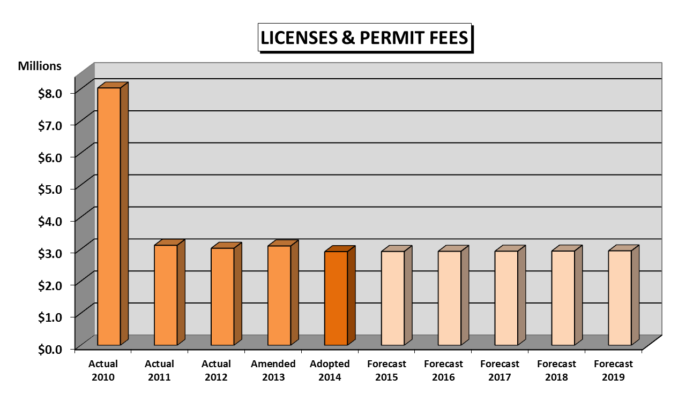This revenue category includes local business tax receipts issued to authorize businesses to operate within the City limits and development permits issued to authorize building and construction within the City limits. The adopted revenue for FY 2014 is $2,924,286, which represents a 5.7% decrease from the FY 2013 amended budget. A conservative approach to growth in new businesses (Occupational Licenses) was included in FY 2014.

\**The Building Permit Fees were included in the General Fund and moved to the Building Fund as of FY 2011.*

**Intergovernmental Revenue**

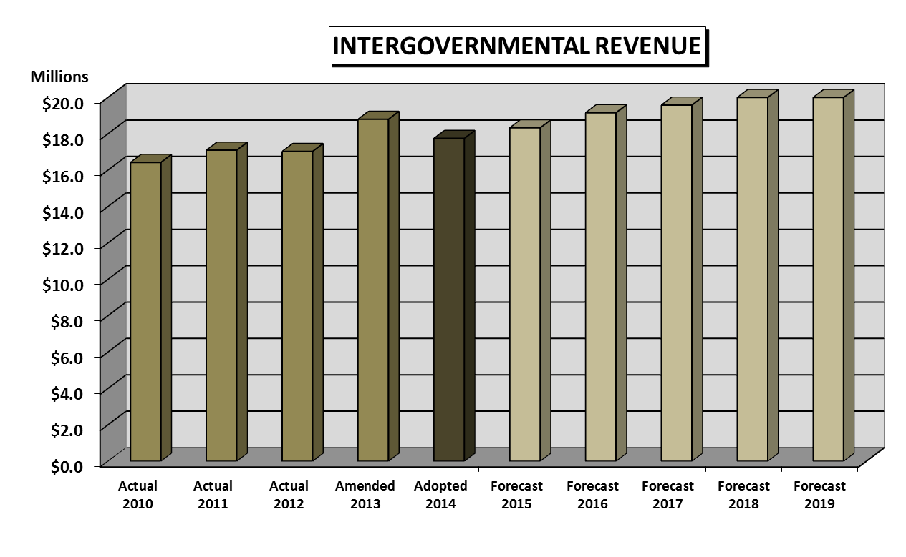This revenue source is recurring State shared and County shared revenue. The State of Florida shares motor fuel, alcoholic beverage license, and sales tax revenue with local governments based on population. Broward County provides gasoline tax and local business tax receipt revenue. The adopted revenue for FY 2014 is $17,749,691, which represents a 5.6% decrease from the FY 2013 amended budget, primarily due to an unfunded mandate for emergency 911 services in FY 2013 that included revenue sharing for 911 services, and reductions in motor fuel taxes and state gas tax related refunds in FY 2014.

**Fines & Forfeitures**

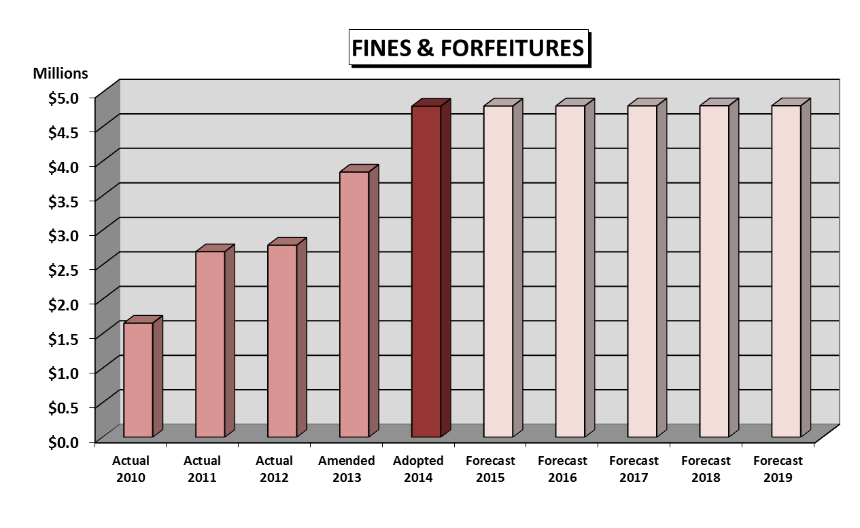This revenue category includes fines for traffic and other violations collected by the County on our behalf through the judicial process. This category represents 1.4% of all General Fund resources. The adopted revenue for FY 2014 is $4,799,918, which represents a 24.8% increase from the FY 2013 amended budget, primarily due to the addition of new camera locations for the Red Light Camera Enforcement Program.

**Miscellaneous Revenue**

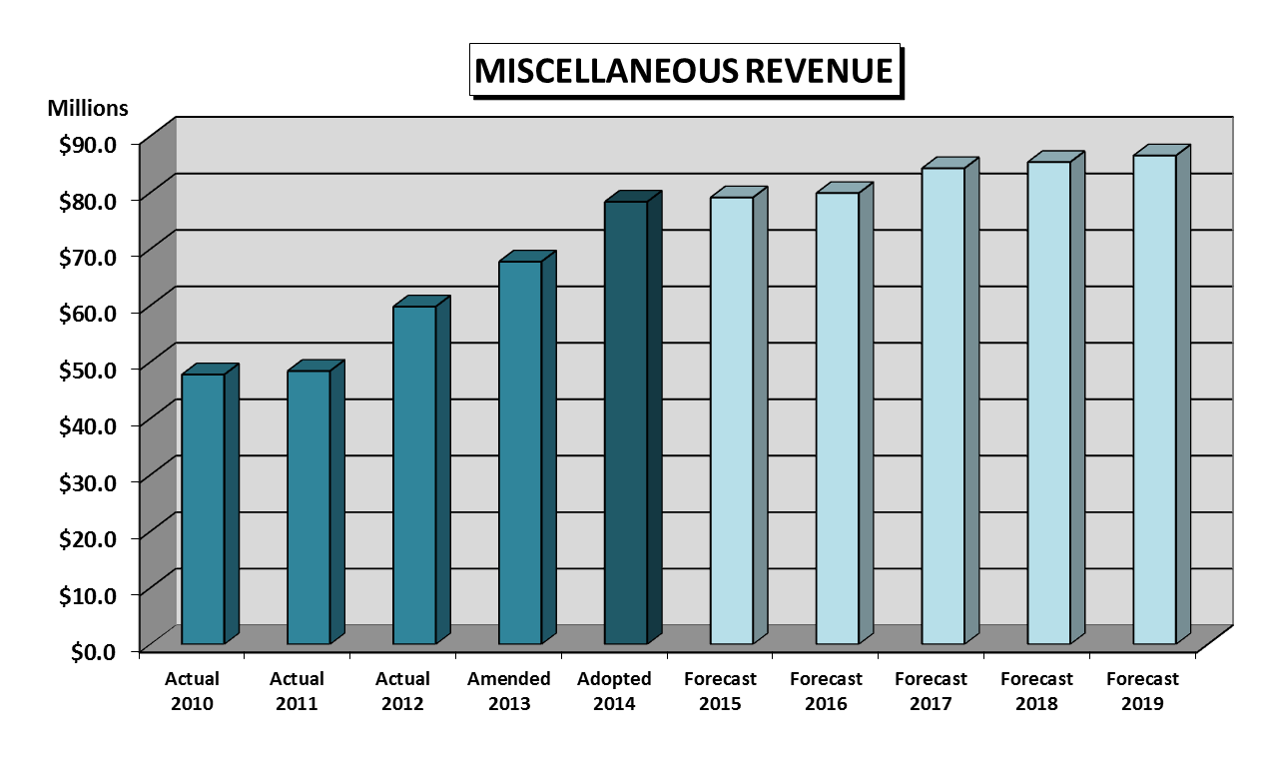This revenue source includes interest earnings, rents, fire assessment, and interfund charges. The fire assessment fee, which appears as a non-ad valorem charge on the tax bill was adopted at $225 per residential parcel in FY 2014. The adopted miscellaneous revenue for FY 2014 including the Fire Assessment is $78,384,413, which represents an increase of 15.6% from the FY 2013 amended budget.